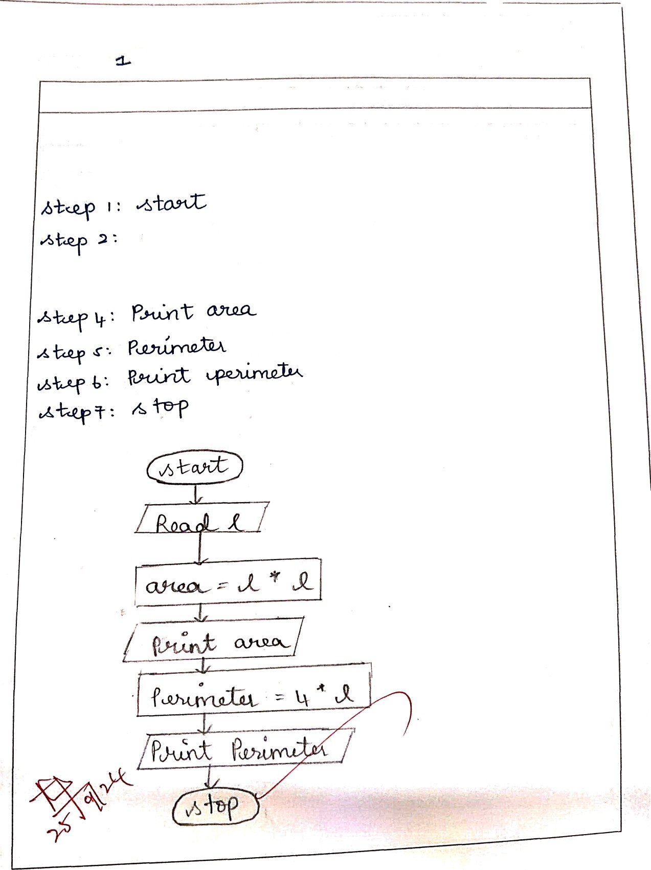

GEz3131 - Programming Using C

Gnleulate Aeea and Perltneter

write« nigoriiiim and draw a F'1oWDliart to Clalculale lhc azea and perime4er of a square.

7£lporlthrrt:

Flowcharl:

. < : <> .»e Enpineering, RajalaMh« Engjneering College

Gl222131 - í’fOJfommíricJ Using C

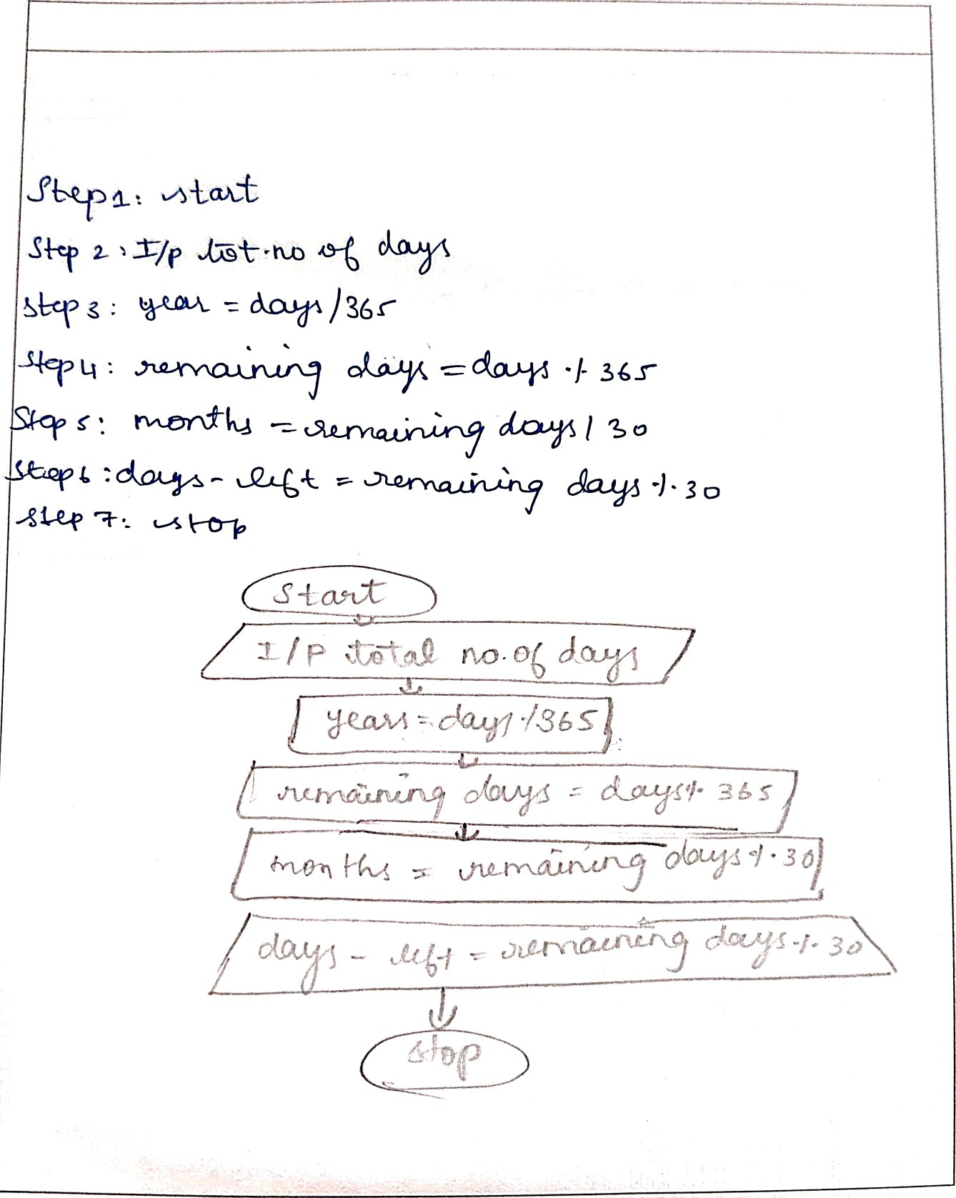

GEZ3131 - I'roc3rainming Using G

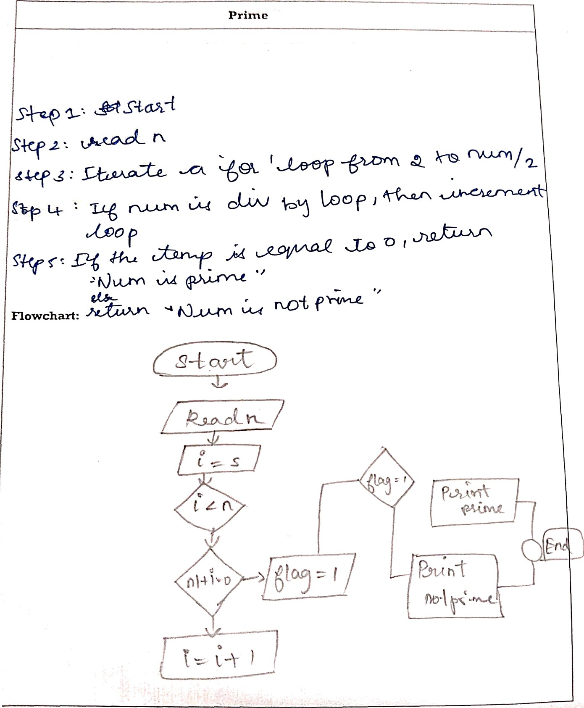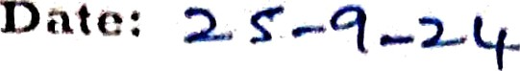



Wzzte azt AJpoz?tIzrrz aztct ctxztw a E'1owcï azt to o1tectt wÏtctl er t1te g1vozt /tu/z¿g y jg j>y yzt

I E23131 - Programming Using G

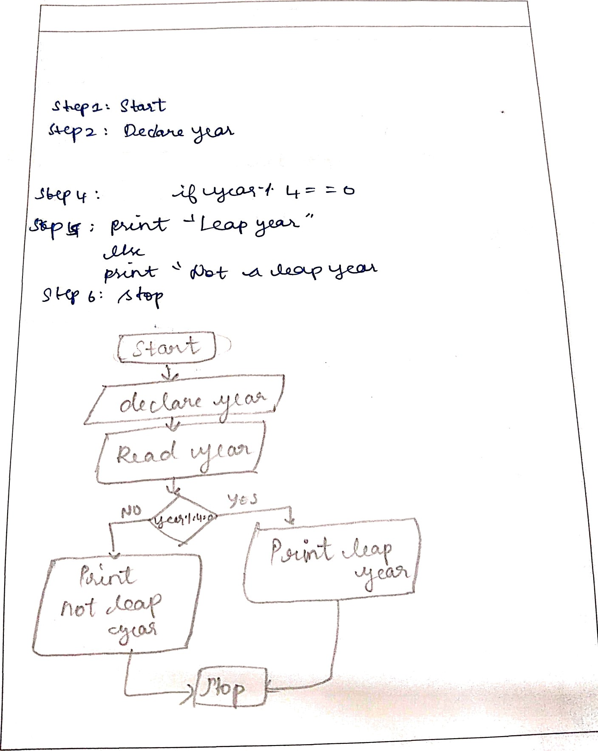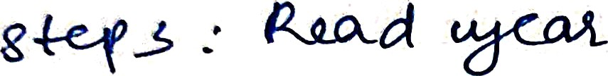



LoapYear

w Jp Yl Jp pjjh pjqq q2q g ylowchnrt to olteclt whether the given year is Leap

year or not.

A1goinhm:

Flowchart:

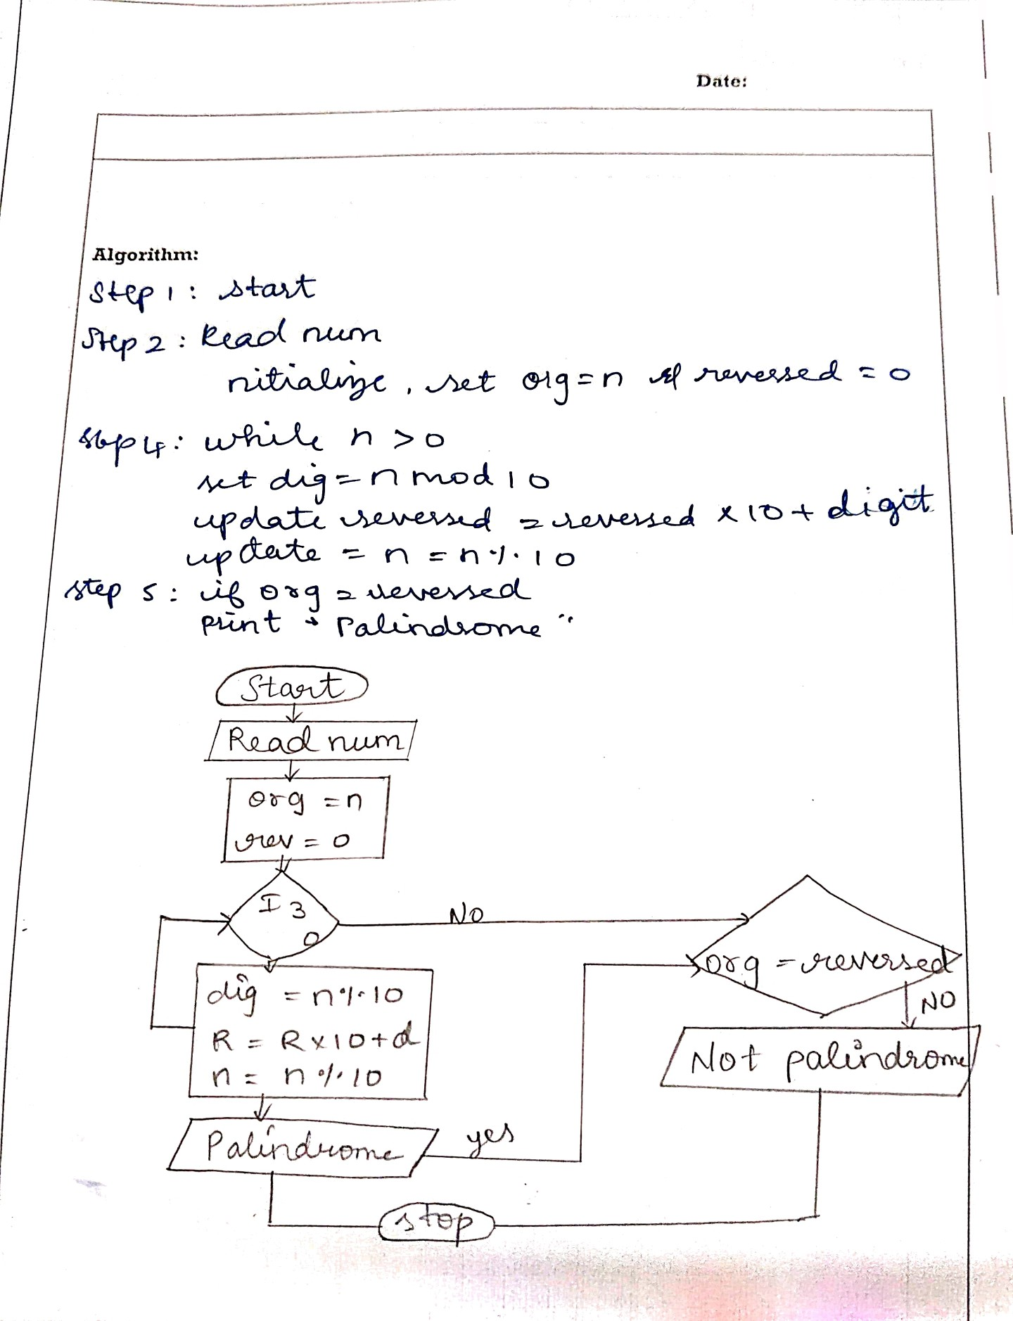GE23131 - Programming Uaing D

Ex. no.:

pn11i:dromo Number

Write an Algorlth\*\*\* &nd dFR « riosv•ann to cheeli Wltettier the ylvcn nurriher in

palzndrome number or not•

F]owchaN:

n >

